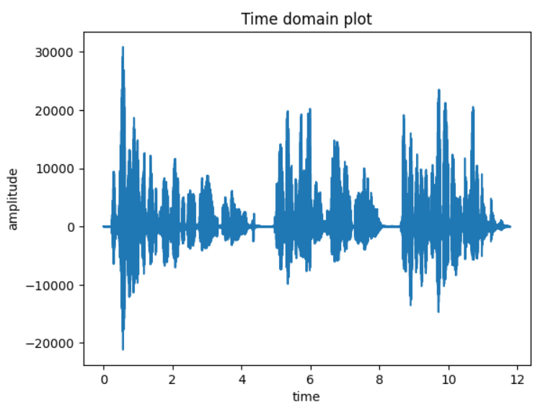1.a) Time domain plot

1.c) Voiced frame

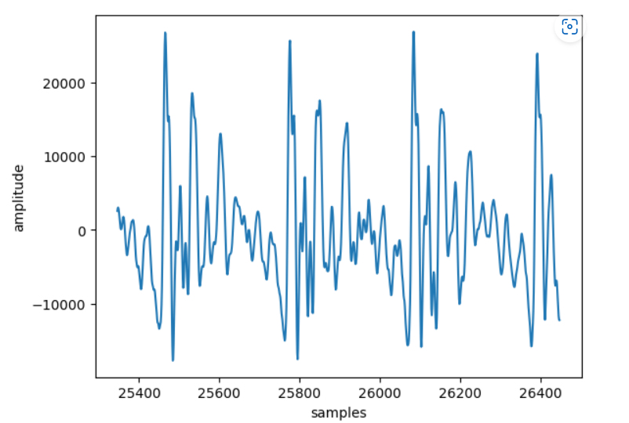

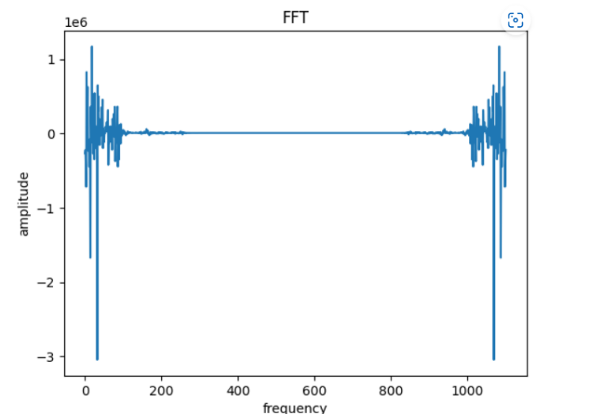1.d) FFT

1.e) Log plot

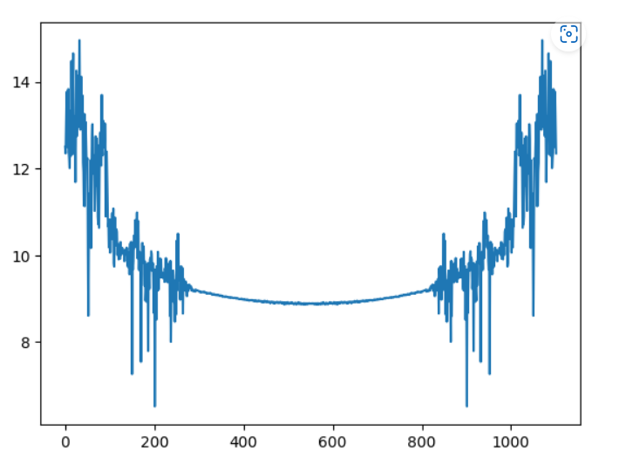

1.g) Inverse Fourier transform

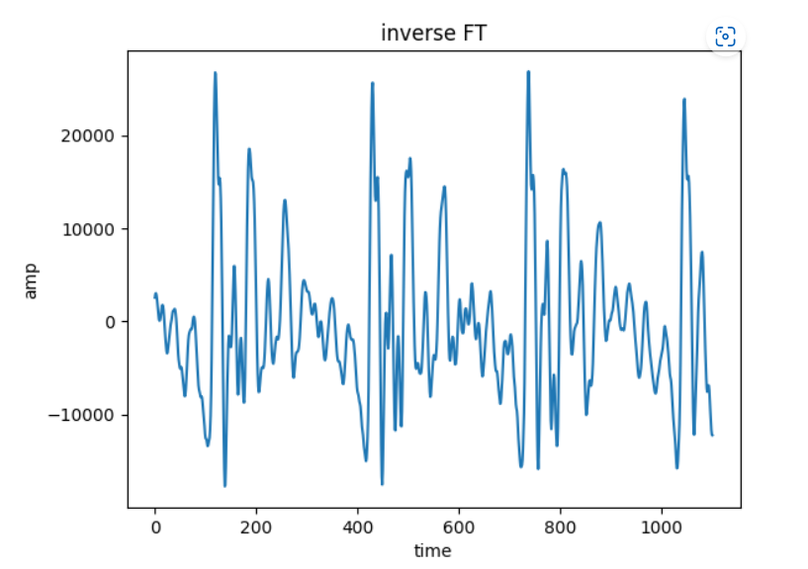

1.h) Observation:

2.a)

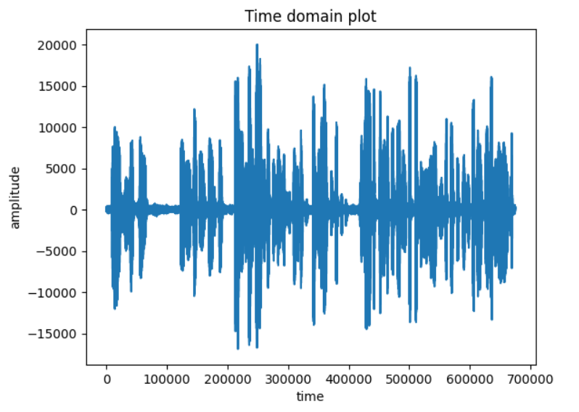

2.c) Zero crossing rate=315

2.d) Energy = [ 8048.6131 , 43702.9973 , 1082729.0172 , 2312295.252 , 1540660.9816

1547986.7624 , 1110566.4799 , 99372.2698]

In the list, first two values (unvoiced frame) lies in the range of multiple of thousands & ten thousands and next five values (voiced frame) lies in the range of lakhs which is high compared to unvoiced frames

Therefore, energy is high for voiced frames and low for unvoiced frames.

2.e) Frames (3,4,5,6,7) are voiced where some stationary is present.

Frames (1,2,8) are unvoiced where the signal is not stationary and looks like a noise

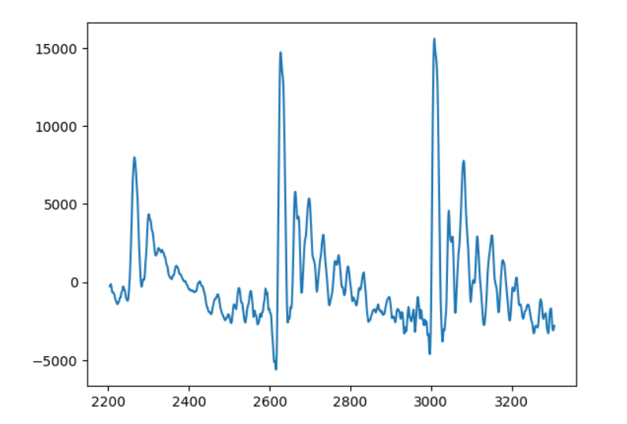Voiced frame (frame no -3)

Unvoiced frame (frame no-2)

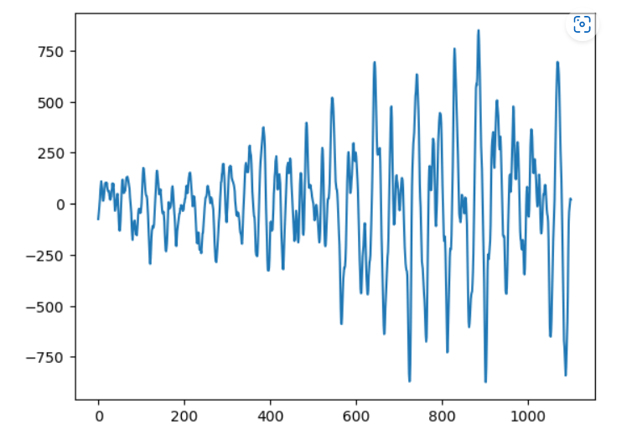

4.a) Time domain plot - lataji_nrm.wav

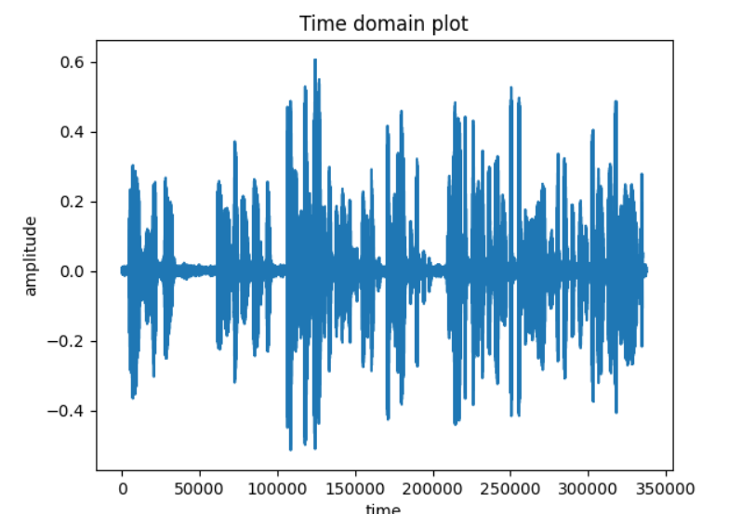

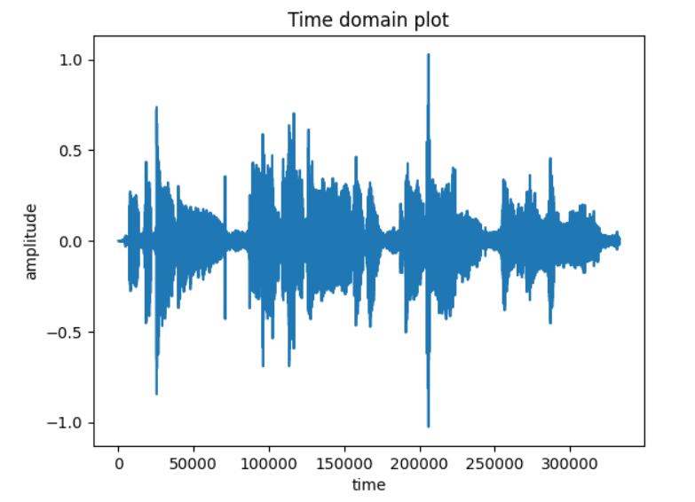4.a) Time domain plot- lataji_sng.wav

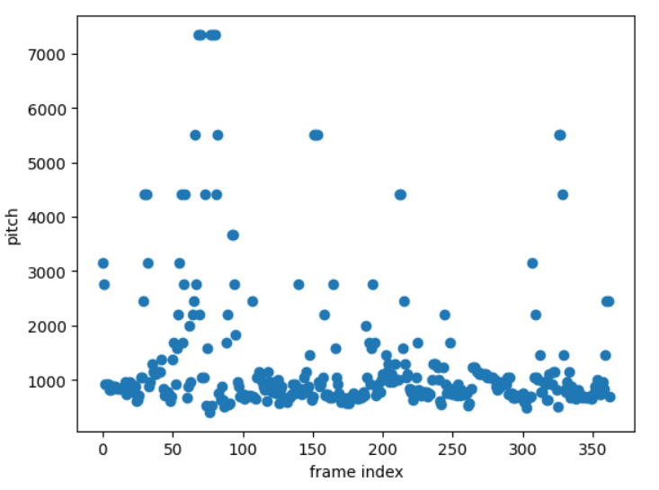4.b) Pitch contour - lataji_nrm.wav

4.c)

4.b) Pitch contour - lataji_sng.wav

